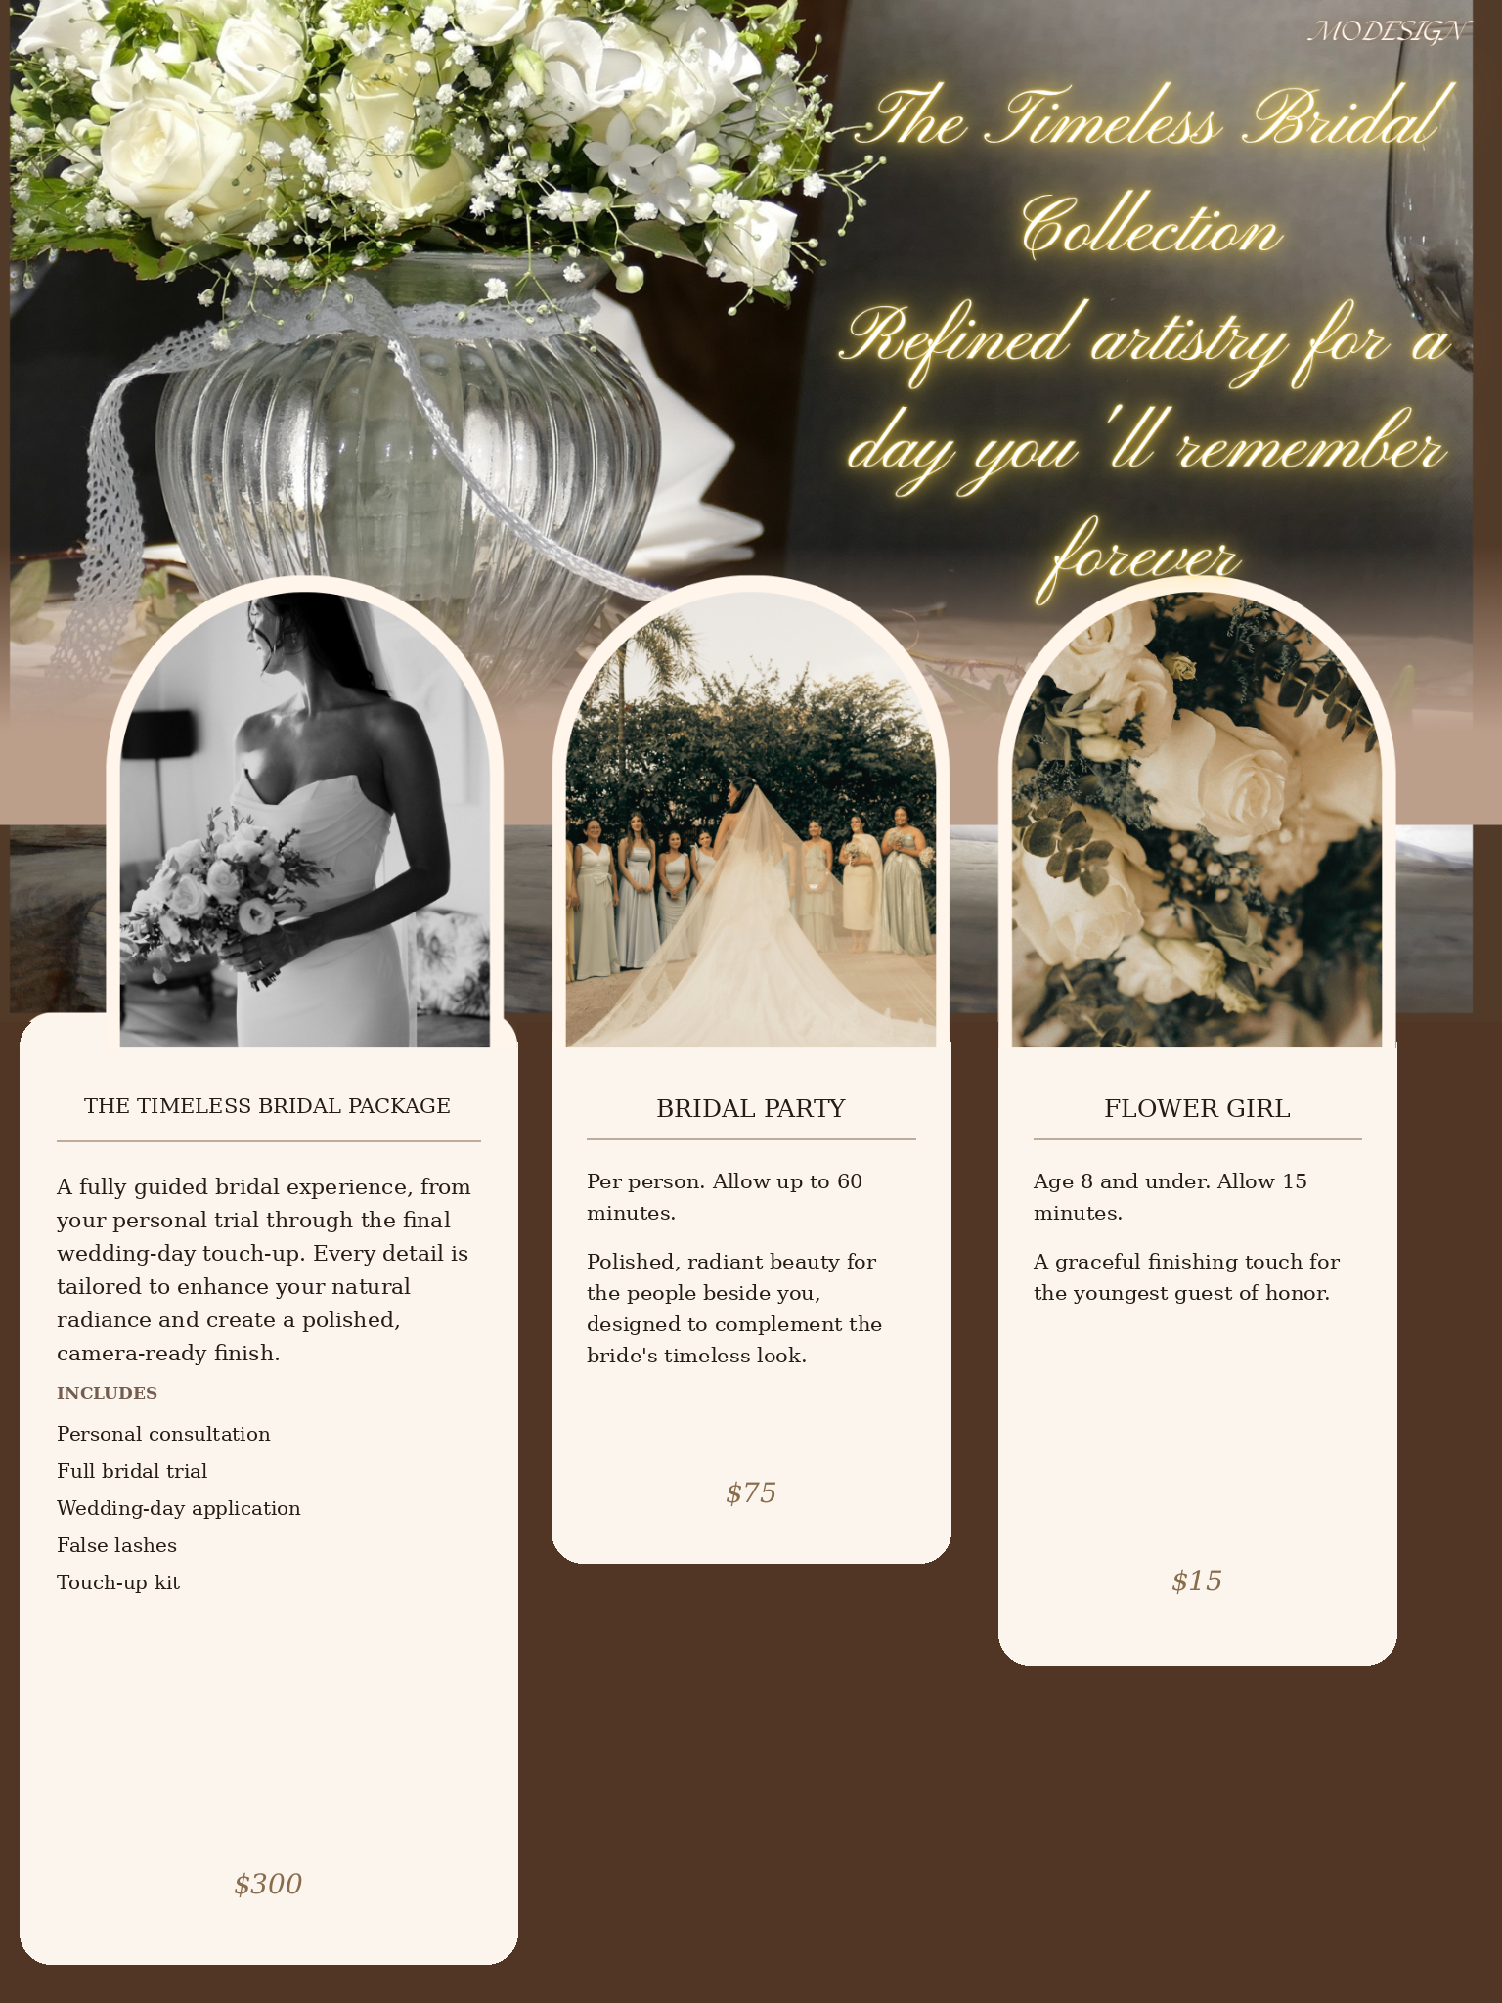
$8 each
$50 each
$200
Age 8 and under. Allow 15
minutes.

A soft, graceful, touch of makeup for the youngest guest of honor.
Allow up to 60 minutes per person.

Polished, radiant makeup for
the people beside you on your special day. Designed to complement the bride's timeless look.
A fully guided bridal experience, from
your personal makeup trial through the final
wedding-day touch-up. Every detail is
tailored to enhance your natural
radiance and create a polished,
camera-ready finish.

INCLUDES
Personal consultation
Luxurious skin care prep
Full bridal makeup trial
Wedding-day makeup application
False lashes
Touch-up kit
Flower Girl
Bridal Party
The Timeless Bridal Package

